The Science of BioGeometry

Jerry Gin, PhD

Introduction
"Back to a Future for Mankind^{[1]}" is an appropriate title given by Dr. Ibrahim Karim to describe his book on BioGeometry. BioGeometry is a science, which has been rediscovered from ancient times and can bring healing into our modern culture. The Great Pyramids of Egypt and the main cathedrals and mosques of Europe and the Middle East used tools, which are basic to the field of BioGeometry for laying out their structures. They understood the energies of ley lines and the Hartmann and Curry grid lines of the earth. Subtle energy emissions from scepters, such as the Ankh and Ouadj, provided healing and detection of these energies as seen in Figure 1 on ancient Egyptian tools.
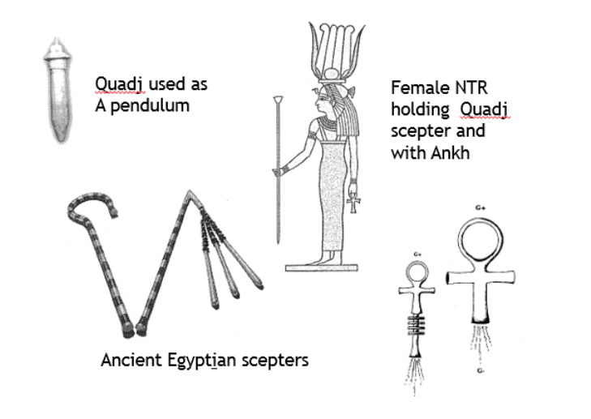
Figure 1. Ancient Egyptian Tools1 to Emit and Detect Energy Qualities ^{[1]} to Detect Energy Qualities
Per Dr. Karim, the definition of BioGeometry is: "The science of establishing harmony in energy quality exchange between biological fields and their environment, through the use of a design language of form, color, motion and sound." It is the resulting subtle energy harmony, which brings about the healing qualities of BioGeometry.
BioGeometry is the term coined by Dr. Ibrahim Karim, the founder of this science and re-discoverer of this ancient scientific paradigm. He is a graduate of the Federal Institute of Technology, Zurich, Switzerland (D.Sc./Dipl. Arch.-ETH), where he studied architecture. He served in advisory positions in Egypt to the Ministers of Health, Culture, Tourism and Scientific Research. He is also head of the Architecture and Industrial Design Firm Alemara, founded by his father Dr. Sayed Karim in 1939.
To understand BioGeometry, it is necessary to achieve an understanding of 'Physical Radiesthesia', the 'physics of quality', in which we experience, the concept of resonance and octaves, the energies, which produce the greatest amount of harmony and the tools for the detection of the energies. These will be explained in the sections below. The beneficial aspects of creating harmony with these energies, is clearly seen in the studies conducted by Dr. Karim.
Physical Radiesthesia, Egyptian Science and Architecture
It was the French Physical Radiesthesia scientists who rediscovered the ancient tools used by the Egyptians. While working in Egypt, Ibrahim Karim was sent to Paris on a work assignment. He had developed interest in the scientific aspects of Radiesthesia and, as a result, decided to visit the 'Maison de la Radiesthesie'. The lady who greeted him asked Ibrahim if he was Egyptian, and when he said "yes," she brought him downstairs to give him stacks of dusty books and tools about Physical Radiesthesia. Apparently, a clairvoyant had told the lady that an Egyptian would be coming and he would be reviving the ancient physics from Egypt and contribute to the field of Physical Radiesthesia. Advances in Radiesthesia had been negatively impacted when one of the pioneers in the field, Leon de Chaumery, was found in his lab by his fellow Radiesthesist, Antoine de Belizal, dead in a mummified state. Chaumery had built an amplification system for these subtle energies and had not known that one form of the energies is detrimental to health.
In the field of Physical Radiesthesia, the tools used can detect energies, which are in resonance with the colors found in the electromagnetic spectrum. If one brings a sphere outside, the portion of the sphere facing the sun would be in resonance with the color green. As one goes around the sphere to the right, the colors are blue, indigo, violet, ultraviolet, white and negative green (grey) at the opposite side of green. As one goes to the left of the sphere, the colors are yellow, orange, red, infrared, black and negative green (grey) at the position opposite green. If one draws a 2-dimensional circle, the position at the north resonates with green, south is negative green, east is violet, and west is red. This is illustrated in the Color Distribution in Radiesthesia/BioGeometry in Figure 2.
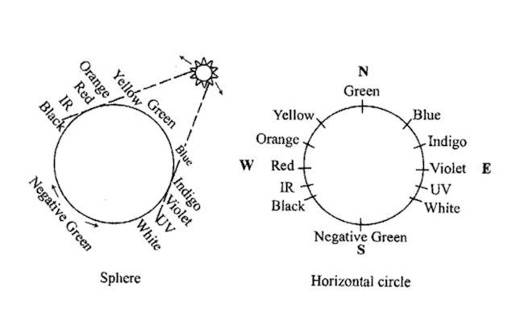
Figure 2. Color Distribution in Radiesthesia/BioGeometry ^{[1]}
If one draws a hemisphere, green is no longer associated with the points of a compass. The top of the hemisphere is green and the bottom is negative green. The other colors of the spectrum are distributed as shown in Figure 3.
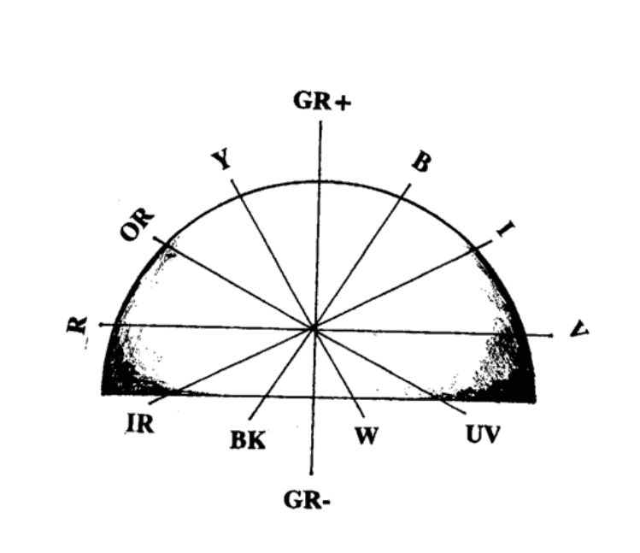
Figure 3. Separation of Colors on a Hemisphere ^{[1]}
The colors around a pyramid are shown in Figure 4. For a hemispherical dome, the energy of green is at the top of the dome and negative green is below the dome. Negative green is considered a carrier wave since it penetrates the structure to the opposite side as seen in Figure 5. As can be seen, both the pyramid and dome are equivalent in that green is at the top of the structure and negative green is emitted below the structure.
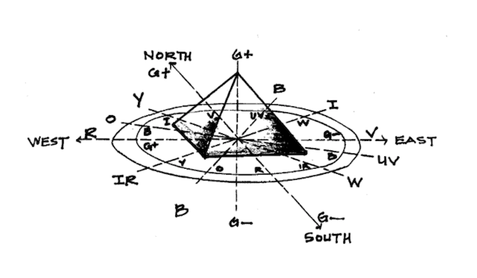
Figure 4. Color Distribution with a Pyramid ^{[2]}
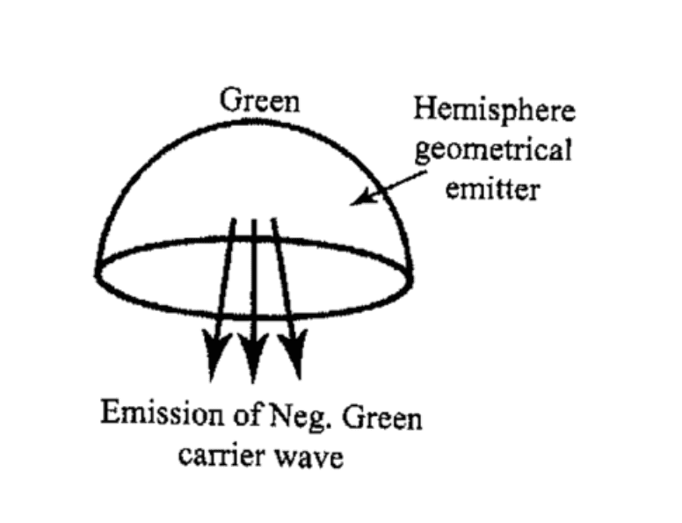
Figure 5. Hemispherical Dome -- Distribution of Green and Negative Green ^{[1]}
Analogous to an electromagnetic wave, there is a vertical and a horizontal component to the energies of the Radiesthesia colors. In the electromagnetic waves, the vertical component is electric in nature and the horizontal component is magnetic in nature (the vertical and horizontal nomination is only used to show that they are perpendicular to each other even when the wave is rotating). For the energies of the Radiesthesia colors, the horizontal component is beneficial whereas the vertical component is detrimental to health. Chaumery, the French Radiestheist had built a series of hemispheres to amplify the negative green energy; unfortunately, it also amplified vertical negative green which resulted in his death and mummification.
The ancient architects understood the phenomena of harmful and beneficial aspects of these energies. They knew that introducing certain artifacts on domes and pyramids corrected for the detrimental aspects of vertical negative green. For domes, a peak or cross or crescent on top of the dome or an extension of the base such as a square structure corrected for the vertical negative green energy. Thus, domes of cathedrals all have structures for negating vertical green. For pyramids, slight indentation in center of the base on each side negates vertical negative green (seen in the Great Pyramid).

Physics of Quality
Let's now look at the concept of the physics of quality. Science deals with numbers (quantitative), but nature deals with quality (color, sound, shape, angles, numbers, taste, smell, touch, etc.). When one looks at color, a physicist would describe it quantitatively in terms of numbers, using wavelengths and frequencies. A person would describe it as the colors of the spectrum (red to violet), as seen in Figure 6 on the electromagnetic spectrum.
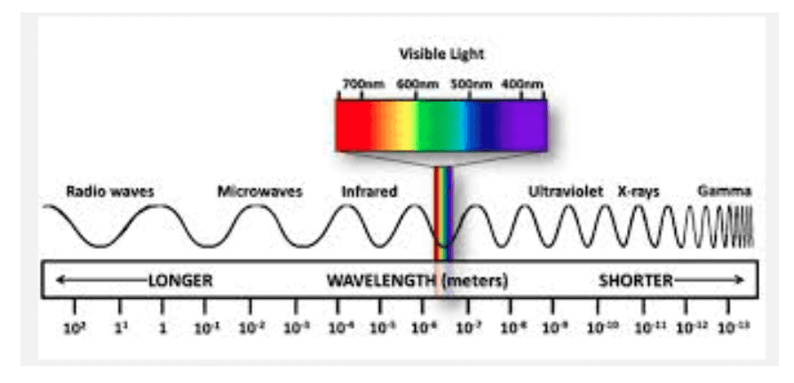
Figure 6. Electromagnetic Spectrum ^{[6]}
To understand how colors, sound, shapes, taste, angles can affect us, one needs to understand the concept of resonance and octaves. If one had a series of tuning forks and strikes one of them, other tuning forks of different sizes, but which are mathematically related because they are the same note at a higher or lower octave), will also vibrate. Similarly, if one had a single string monochord and plucked the string, it would vibrate and other monochords of the same note but at different octaves would also vibrate - as seen in Figure 7.
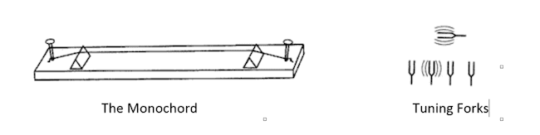
Figure 7. Concept of Resonance and Octaves with Monochord and Tuning Forks ^{[1]}
The color red is just another octave of the musical note "Do" or "C". In BioGeometry, it is understood that vibrations of different octaves have similar effects on us. Musical notes, colors, scents, taste, shapes, design and angles can affect us. Color results from the effect of refraction of angles through a prism on our sensory system and angles are components of shapes. So shapes are actually frozen qualities that affect our energy systems accordingly.
As a human, nerve reactions are the basis for receiving information from our senses. All senses express the same type of nerve reaction. Thus, a given sound can have the same nerve reaction as a given color, e.g. red and "Do." Our nerves also react to geometrical shapes, angles, numbers of units, proportions, etc. via an extrasensory path. This is shown in the Quality of Physics: Sensory Scale diagram in Figure 8.
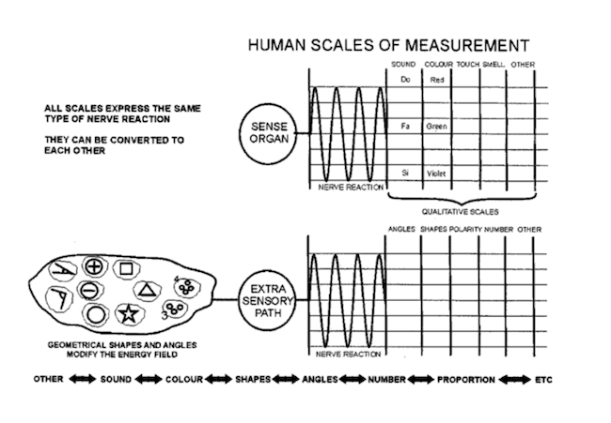
Figure 8. Quality of Physics -- Equivalence of Sensory Scale ^{[1]}
Another way to look at the nature of the quality of physics is to categorize it in terms of the levels of vibratory influence it has on us. Think of the senses as vibrations -- colors as electromagnetic vibrations, sound waves, etc. (level 1). The vibrations produce nerve impulses (level 2). The nerve impulses are translated into a quality of the signal - colors, smells, etc. (level 3). The quality creates a perceived reality based on our memory data bank (level 4). The perceived reality is then projected onto our observed absolute reality within space/time (level 5).

BG3 Energies and the BioGeometry Energy Key
Radiesthesia scientist, Scariatin (a Russian living in Egypt - pseudonym, Enel), detected "horizontal negative green" energy quality in the bodies of Christian saints and used this quality as an indication of spirituality of the person. Dr. Karim then detected the same energy in sacred monuments independent of the bodies. The same energy could be detected in other power spots of the world (certain cathedrals, stone structures such as Dolmens and Menhirs) -- see Figure 9.
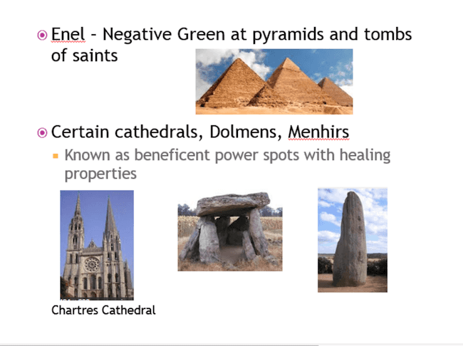
Figure 9. Energies of Sacred Power Sites
Ibrahim Karim carried on the studies of the sacred power spots and the beneficial energies found there. Through years of research, he found two other energy components which were always present at these power sites. These were:
- "Higher Harmonic of Ultraviolet" (Horizontal) -- an energy quality found at dawn (the time of day "where angels manifest & spiritual rituals occur")
- "Higher Harmonic of Gold" (Horizontal) an energy quality depicted as golden halos and auras around heads of saints
Dr. Karim understood the significance of these three subtle energy components named them BG3 (BioGeometry 3). Negative Green, Higher Harmonic of Ultraviolet, and Higher Harmonic of Gold comprise the "One Harmonizing Subtle Energy Quality" that is generally referred to as spiritual. Through his subsequent research, Dr. Karim would establish the harmonizing and healing effects of BG3.
The harmonizing and healing energies of BG3 can be created by shapes, design, color, sound, angles, motion, etc. All motion (vibration) creates secondary compression waves in the environment. If an object (shape, form, color, etc.) is present, the compression waves are affected as shown in the picture of the boat in water (or an electromagnetic wave) in Figure 10.
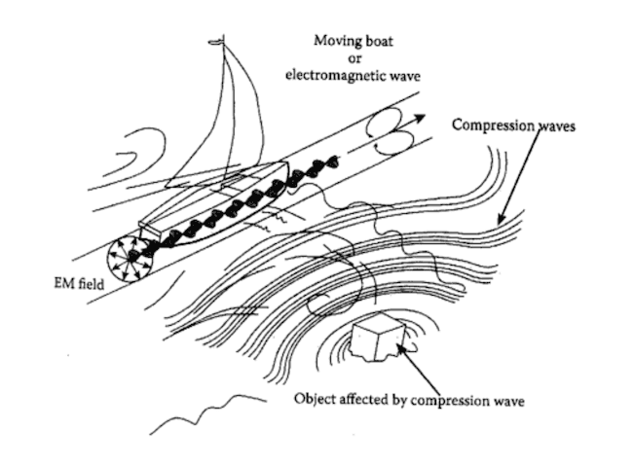
Figure 10. Motion or EMF Producing Compression Waves (Scalar). ^{[1]} All motion produces secondary compression waves in the environment.
This picture forms the basis of the BioGeometry Energy Key showing the effect of Energy Quality movement EQ2 to EQ3 with resultant clockwise and counterclockwise rotation of EQ3 and EQ4. This is analogous to the effect of a flute on surrounding air. A 3-dimensional form of the BioGeometry Energy Key is shown in Figure 11, The BioGeometry Energy Key.
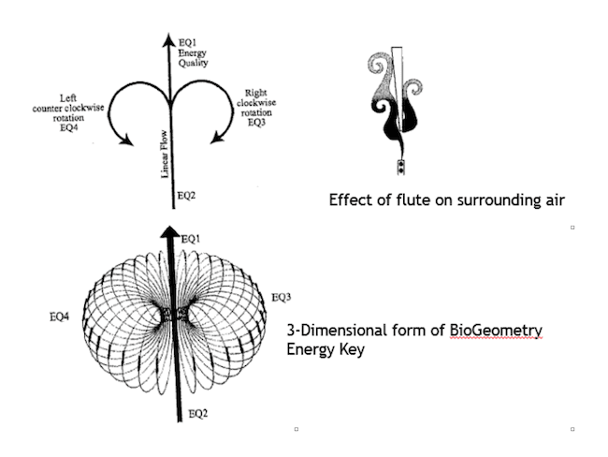
Thus, BioGeometry deals with shapes, colors, sound, etc. to interact with energy fields to produce a balancing effect on multiple levels on biological systems. It focuses on vibrational qualities of 3 energy fields which produces balancing (BG3). The balancing/harmonizing produces positive effects on emotional, mental, spiritual, and physical levels. A way of visualizing the harmonization or regaining balance with BG3 is shown in Figure 12.
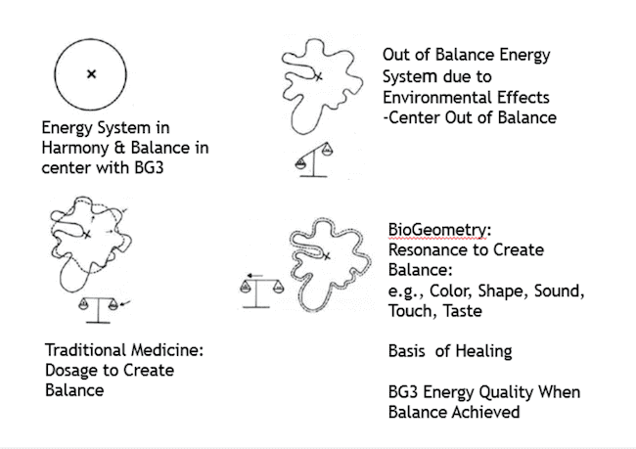
Figure 11. The BioGeometry Energy Key ^{[1]}
With this understanding of the principles of BioGeometry, Dr. Karim was able to demonstrate the effectiveness of this science as seen in the "Examples of the Successes with BioGeometry Tools" section of this article.

On Principles of Tools used In Radiesthesia
In quantum physics, the observer is integral to the experiment. Similarly, the person is integral to use of the tools of Radiesthesia. Specialized pendulums are used. Pendulums in Radiesthesia detect vibrations in a way that is analogous to the monochord. In the Monochord, there is amplitude and wavelength as shown in Figure 13; in operating the pendulum, the same concept of amplitude and wavelength applies.
The principle for using the pendulum in Radiesthesia is called "Physical Radiesthesia". In Physical Radiesthesia, one looks for resonance with the energies by observing a clockwise rotation in the pendulum whenever resonance occurs (see Figure 14).
This concept is distinctly different from that used in mental dowsing where typically a yes or no answer is desired. Pendulums are constructed in a way to detect energies. An example is a virtual cone pendulum where a disc which can be moved up or down the axis of the pendulum can be correlated with angles which, in turn, can be shown to be in resonance with the energies of different colors (wavelengths). These principles are shown in Figure 15.
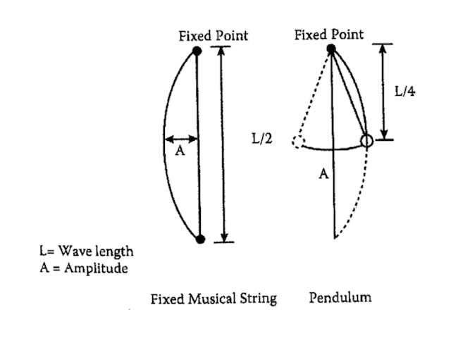
Figure 13. Correlation of Musical String Instrument with a Pendulum ^{[1]}
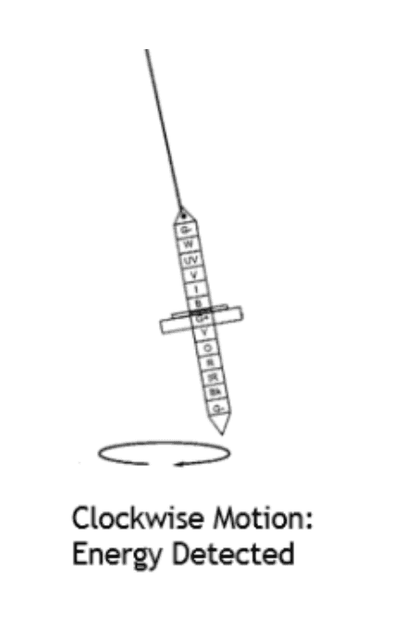
Figure 14. Clockwise Motion of Virtual Cone Pendulum in Physical Radiesthesia/BioGeometry for Detecting Energy
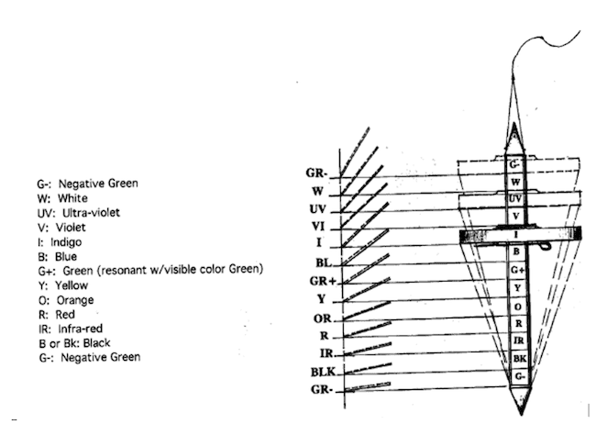
Figure 15. Virtual Cone Pendulum and Conversion of Colors into Geometrical Angles to Give Color Calibration Through Shape ^{[2]}, ^{[3]}, ^{[5]}

Examples of the Successes with BioGeometry Tools
Below are example of the use of BioGeometry to create harmonization solutions with EMF, viral infection using BioSignatures, harmonization of water, effects on poultry breeding without antibiotics, agricultural solution without use of pesticides, and growth of sweet potatoes in salt water.

Harmonizing the Negative Effects of Electrosmog
Everything in nature communicates by waves. Electromagnetic Fields (EMF) are now being created with our modern technology, which are a thousand times stronger than seen in nature. Cell towers, cell phones, WiFi, cordless phones, fluorescent lights, computers, etc. abound in our modern culture.
In autumn of 2002, Swisscom installed a mobile cell tower at the highest point in the city of Hemberg, Switzerland -- on top of the church tower. The numerous negative effects of electrosensitivity on humans, animals and birds were immediate. There were complaints of sleeping disorders, headache, concentration deficiencies, and many other symptoms, which are now known to be caused by EMF's. Brooding songbirds and bats left the vicinity of Hemberg. The people of Hemberg complained vehemently. As a result, the Mediation Authority for Mobile Communication & Environment (OMK/MAMCE) convinced Swisscom, the main telecom provider, to bring in Dr. Karim to see if the use of BioGeometry tools might help. The project with Ibrahim Karim was initiated August of 2003. The aim was to create a harmonic energy quality surrounding humans, animals and plants in the city of Hemberg. BioGeometry tools were used to harmonize electrical cables, antennas and homes of affected persons.
Dr. Krarim created the Hemberg Emitter to harmonize the source of EMF emissions from the cell tower. The Home Kit with Cubes containing BioGeometry etchings to harmonize EMF was created. Figure 16 shows the Hemberg Emitter as well as the Cubes used in the Home Kit. The results for the city of Hemberg were spectacular -- the problem of electrosensitivity was eliminated, birds and bats returned. The study was carried out and fully documented under the auspices of Swiss Mediation Authority for Mobile Communication and Environment (MAMCE) and the telecom provider -- Swisscom. A booklet was published by a Hemberg author titled the Miracle of Hemberg. A summary of the results on frequency and severity of complaints of electrosensitivity before and after implementation of BioGeometry devices are shown in Figure 17.
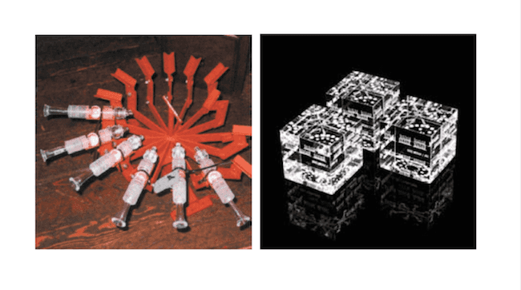
Figure 16. Hemberg Emitter and Cubes in Home Kit . The Hemberg Emitters are shown with the holding device for harmonizing the EMF disturbance at its source. Home Kit with Cubes are able to harmonize homes of affected persons.
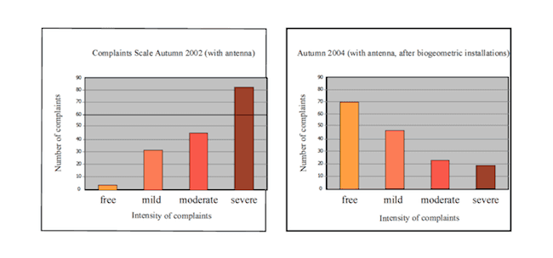
Figure 17. Summary of results on frequency and severity of complaints of electrosensitivity before and after implementation of BioGeometry devices ^{[1]}
As a result of the success in Hemberg, the Swiss invited Dr. Karim to repeat the process in the city of Hirschberg. The results were documented by Swiss TV Channel 1. Results were again successful and produced the Miracle of Hirschberg. Dr. Karim was then offered a long term contract for the whole country of Switzerland, which he declined as he had moved to Canada.

BioSignatures for Health
BioSignatures are linear diagrams which resonate with the energy patterns of organs in the body. The BioSignatures produce harmonization and introduce BG3 in the organs, clear energy blockages and result in energy balancing. Examples of BioSignatures are shown in Figure 18. The BioSignatures can be worn as pendants or rings with the linear diagrams imprinted on the metal.
An important validation of the value of BioSignatures was the National Hepatitis C Project conducted by the National Research Center in Cairo. The purpose of the study was to determine the relative efficacy of various drugs and remedies in treating hepatitis C. The duration of the study was 6 months and efficacy was determined by measuring liver enzyme levels, which are indicative of liver damage. The results showed that other remedies/drugs were in the 20-30% range, but the best result was 90% with BioSignatures.
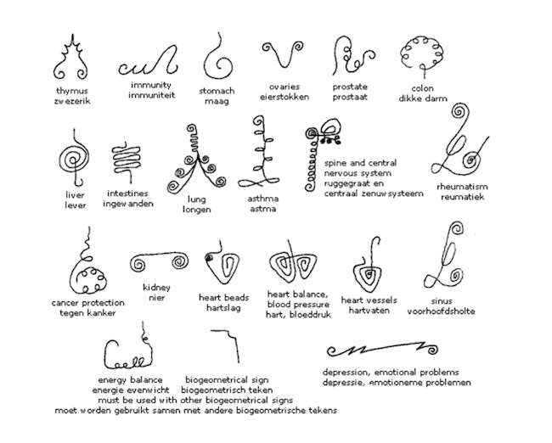
Figure 18. BioSignatures are linear diagrams which resonate with energy patterns of organs and functions of the body, producing harmony and introducing BG3 to clear energy blockages and enhance energy balance. ^{[1]}

Effect of Home Kit Cube on Water
Dr. Masaru Emoto, author of The Messages from Water [4] , worked with Dr. Karim and his BioGeometry Cube in the Home Kit. When the Cube was placed in a room with water, the subtle energy from the Cube resulted in balanced, beautifully formed crystals when the water was frozen. In his book, Dr. Emoto showed that water impregnated with good energy quality (e.g., Love) formed beautiful, well-balanced hexagonal crystals, while water impregnated with bad energy quality produced badly formed and unbalanced crystals. The crystals in the presence of the Cube showed the water was exposed to good energy qualities. The research was carried out at the Hado Life Europe Laboratory in Lichtenstein, Switzerland. Figure 19 shows photos of water from the same source exposed to the Cube from the Home Kit and not exposed. The results clearly show the effect of the Cube on the crystalline pattern of the water when frozen.
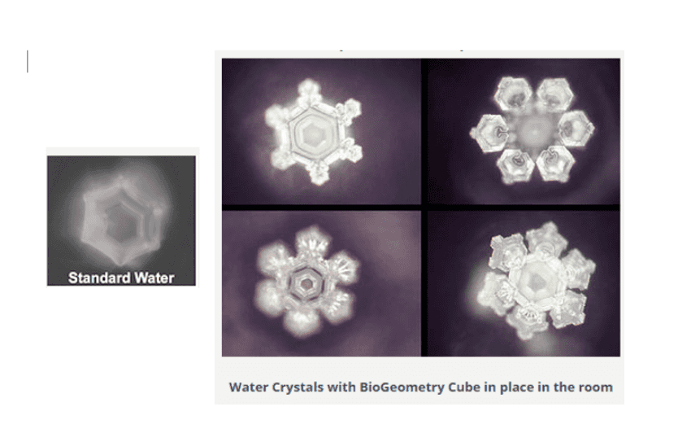
Figure 19. Cubes in Home Kit Producing Harmnonization in Water ^{[1]}

BioGeometry and Poultry Breeding
A research study was carried out by Dr. Ahmed Hussein of Suez Canal University and the Ministry of Agriculture. The breeding facility was harmonized using energy balancing BioGeometry solutions. The results showed significantly increased growth and quality of the chickens, without use of antibiotics, hormones or vaccinations as compared to chickens grown by standard methods. At present BioGeometry Canada is working with Nutrinor, in Quebec Canada, in its third year of chicken production without vaccinations, hormones or antibiotics.

BioGeometry and Agricultural Solutions
In 1999, a project was carried out by Prof. Peter Mols of Wagengingen Agriculture Univiersity on 'balancing' an apple orchard without the use of pesticides. The results showed a noticeable decrease of parasite infection due to the raised immunity of the plants making them more resistant to parasites without any extermination of any form of bacteria that could be beneficial to the plant. The resulting apples had a livelier taste, smell and color as well as longer shelf life compared to average apples.

Salt Water Planting Experiment
Sweet potatoes were grown in salt water from the Red Sea. The control was a sweet potato grown with normal water (no salt). The experiment was carried out with untreated salt water and was compared with salt water which was treated by BG3 based on the shape of the container holding the water. Results are shown below:

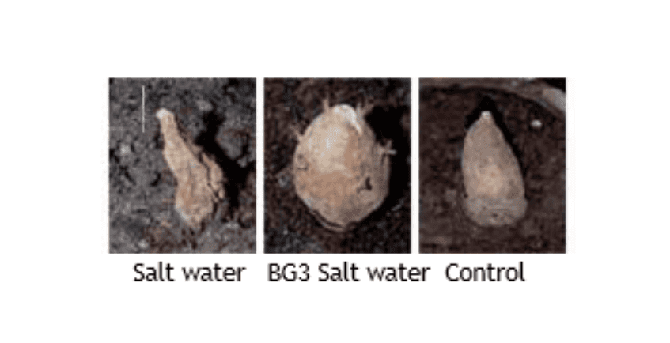
Figure 20. Growth of Sweet Potatoes in Salt Water ^{[1]}
Key words: BioGeometry, Radiesthesia, Subtle Energies, harmonization, resonance, octaves, harmonics, BG3, BioSignatures, EMF

Acknowledgements: Acknowledgement is given to my mentors and their books: Dr. Ibrahim Karim, Back to a Future for Mankind: BioGeometry, [1] Dr. Robert Gilbert, Egyptian and European Energy Work - Reclaiming the Ancient Science of Spiritual Vibration2, [2] and Kris Attard, BioGeometry Foundation Training, Levels 1,2,3. [3]

References
- Back to a Future for Mankind: BioGeometry, Ibrahim Karim, Ph.D., Dr.SC.,published by BioGeometry Consulting, Ltd.
- Egyptian and EuropeanEnergy Work, Gilbert, Robert J. Ph.D., published by Vesica, LLC.
- BioGeometry Foundation Training, Levels 1,2,3 -- Notebook, Kris Attard, Instructor
- The Messages from Water, Masaru Emoto
- Basic Principles of the Virtual Cone Pendulum, PDF here.
- The Messages from Climate Science Investigations, NASA, www.ces.fau.edu/nasa/module-2/radiation-sun.php

These papers are all copyrighted. Please request permission for additional uses from the author.

